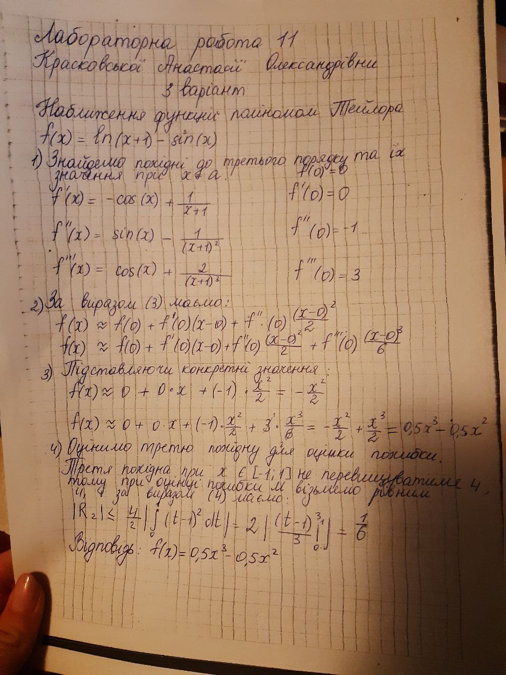

**Код:**

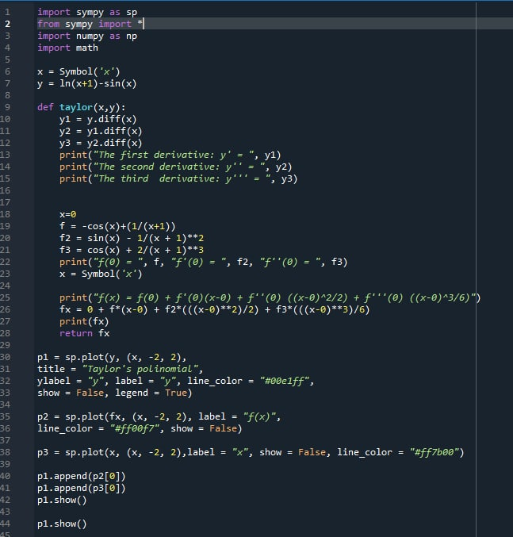

**Результат:**

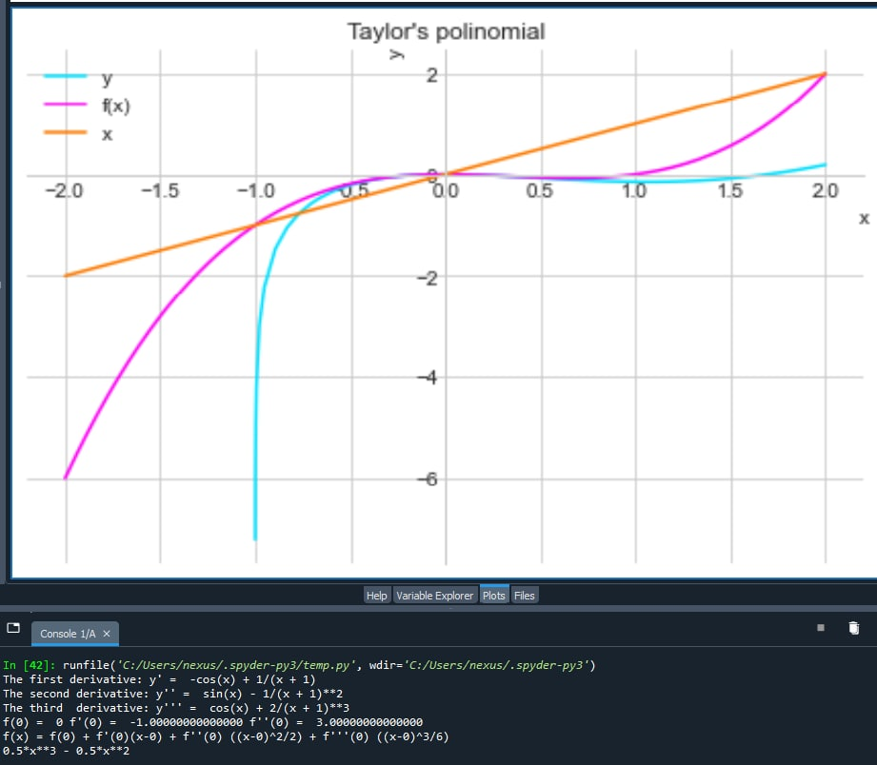

import sympy as sp

from sympy import *

import numpy as np

import math

x = Symbol('x')

y = ln(x+1)-sin(x)

y1 = y.diff(x)

y2 = y1.diff(x)

y3 = y2.diff(x)

print("The first derivative: y' = ", y1)

print("The second derivative: y'' = ", y2)

print("The third derivative: y''' = ", y3)

x=0

f = -cos(x)+(1/(x+1))

f2 = sin(x) - 1/(x + 1)**2

f3 = cos(x) + 2/(x + 1)**3

print("f(0) = ", f, "f'(0) = ", f2, "f''(0) = ", f3)

x = Symbol('x')

print("f(x) = f(0) + f'(0)(x-0) + f''(0) ((x-0)^2/2) + f'''(0) ((x-0)^3/6)")

fx = 0 + f*(x-0) + f2*(((x-0)**2)/2) + f3*(((x-0)**3)/6)

print(fx)

p1 = sp.plot(y, (x, -2, 2), title = "Taylor's polinomial", ylabel = "y", label = "y", line_color = "[#00e1ff](tg://search_hashtag?hashtag=00e1ff)", show = False, legend = True)

p2 = sp.plot(fx, (x, -2, 2), label = "f(x)", line_color = "[#ff00f7](tg://search_hashtag?hashtag=ff00f7)", show = False)

p3 = sp.plot(x, (x, -2, 2),label = "x", show = False, line_color = "[#ff7b00](tg://search_hashtag?hashtag=ff7b00)")

p1.append(p2[0])

p1.append(p3[0])

[p1.show](https://p1.show/)()